App Server and Web Server
- Install nginx and run nginx on port number 81.
Steps:
# yum install nginx
# systemctl start nginx
# systemctl status nginx
# ps -ef (To verify the port numbers)
# ps -ef | grep nginx (To verify inside the folder)
#find / -name nginx.conf
#vi /etc/nginx/nginx.conf
#ls
#cd /etc/nginx (To change directory to etc/nginx)
#ls
#vi nginx.conf (To change the port number)
#systemctl restart nginx
#Verify the IPVP with the updated port number 81 in browser.
Nginx is installed.

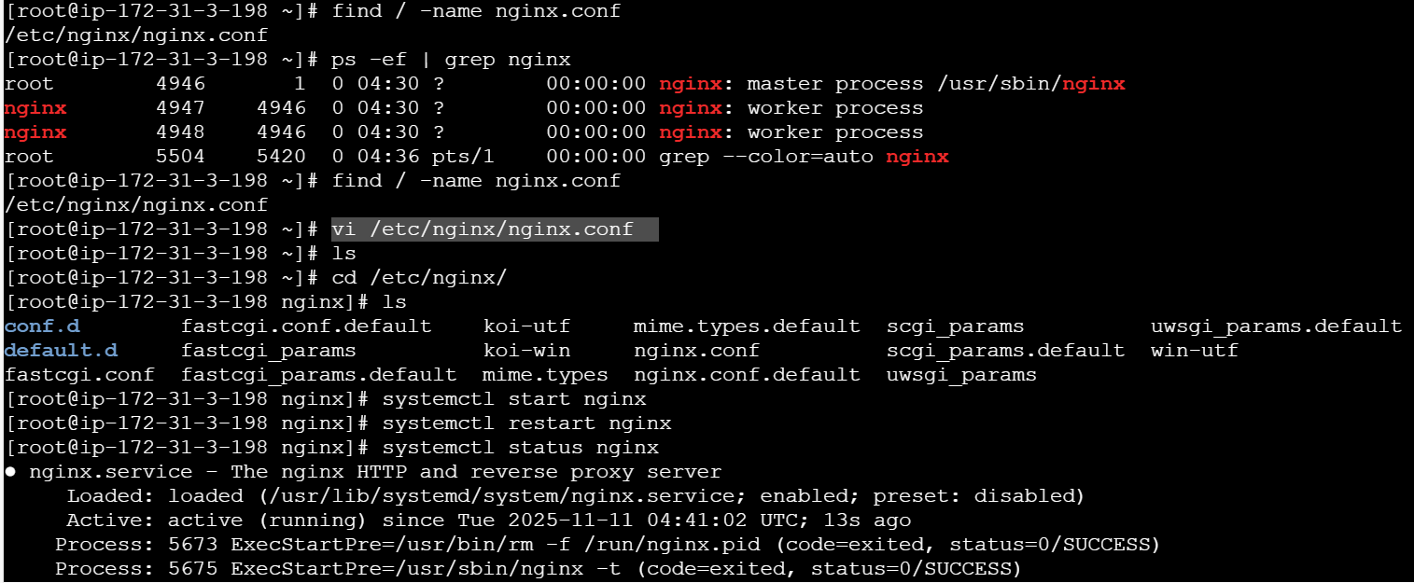


Successfully running nginx on Port-81.
- Deploy a sample index.html file on nginx.

Deployment location -- /usr/share/nginx/html
#cd /usr/share/nginx/html
# vi index.html
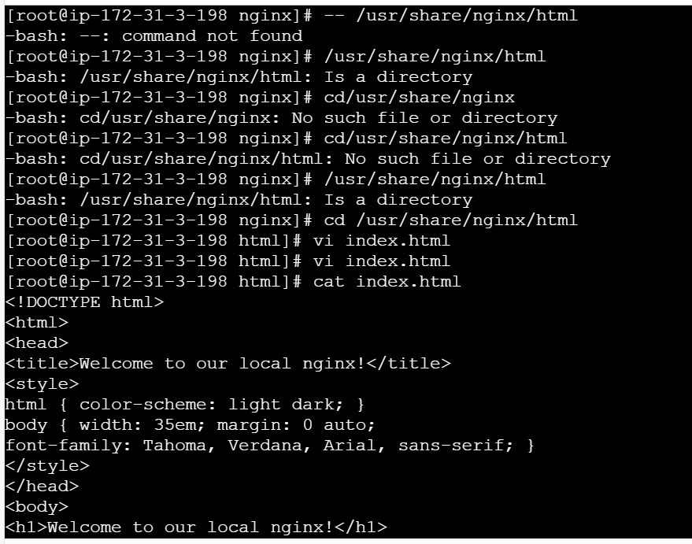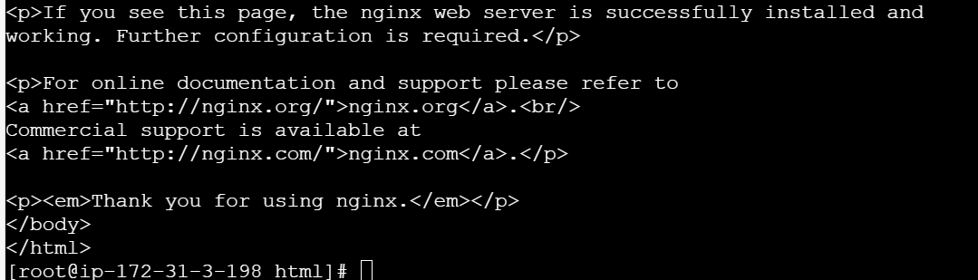

- Install Apache and run Apache on port number 82
Apache (called httpd)
Command: yum install httpd -y
Then start the service using
Systemctl start httpd
To find the path- find / -name httpd.conf
To change the port number from 80 to 82- vi /etc/httpd/conf/httpd.conf
Verify the port number using: netstat -na | grep 82
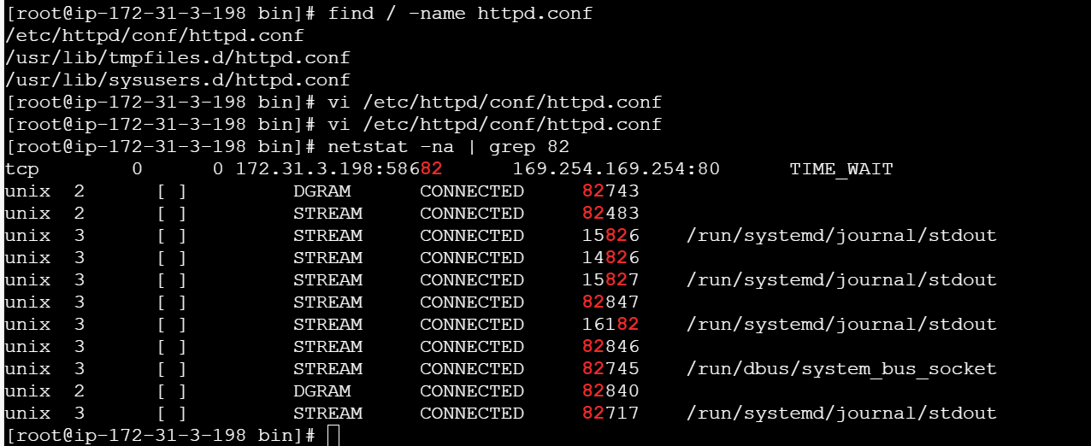

Verify on browser using: ipaddress@portnumber

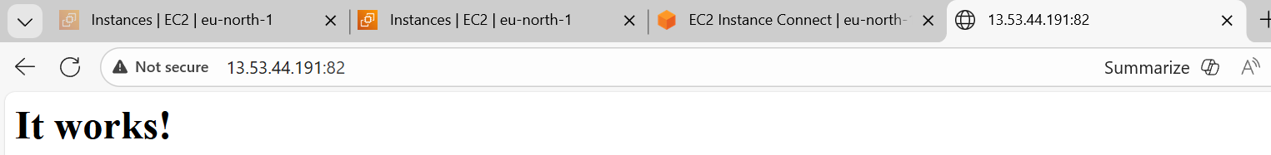

- Install Apache tomcat on port number 8082
Step 1 download link from apache tomcat download
And use Wget command to run
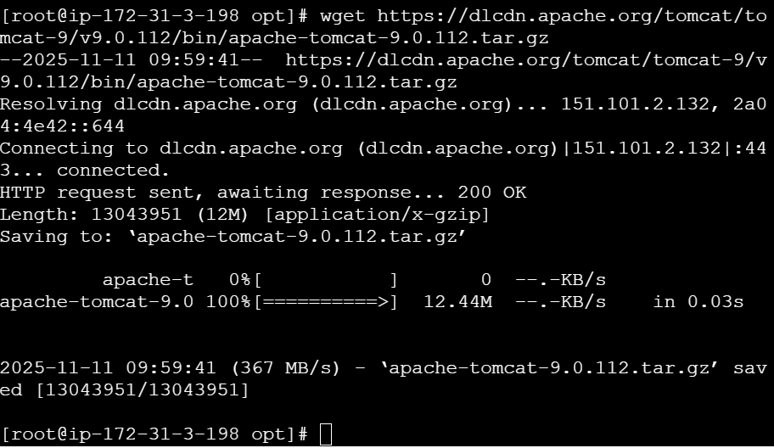
Then list the files using ls and see whether tar.gz file located or not
And use command tar xvf to xtract verbose file
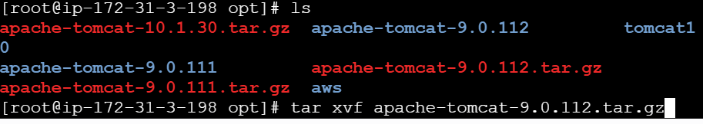
Then change to directory to apache folder
Then list the files
And change to bin
Execute the command ./startup.sh
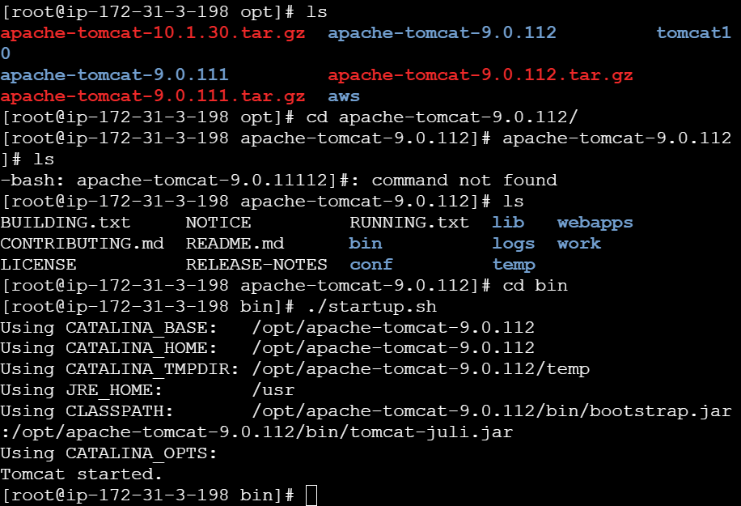
Then check the port using command
Netstat -na | grep 8080
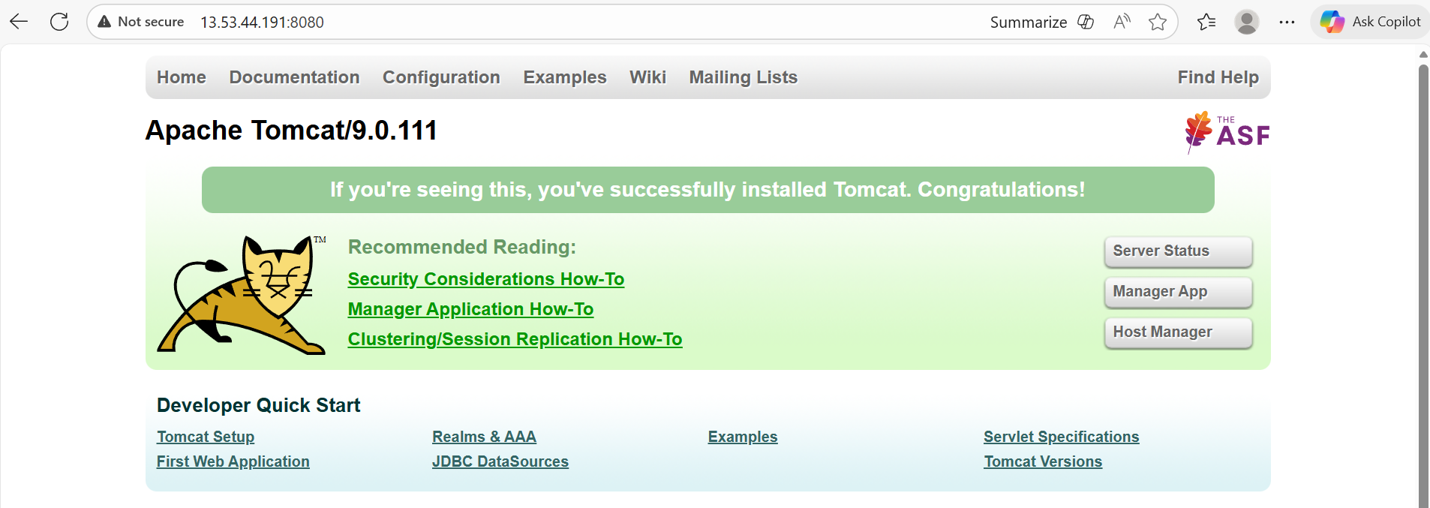
Then change the port number from 8080 to 8082
Step 1 : change directory to cd /opt/
Step 2: change directoctory to cd apache-tomcat-9.0.112/
Step 3: change directory to cd conf/
Step 4: edit port number using vi and file called server.xml and save

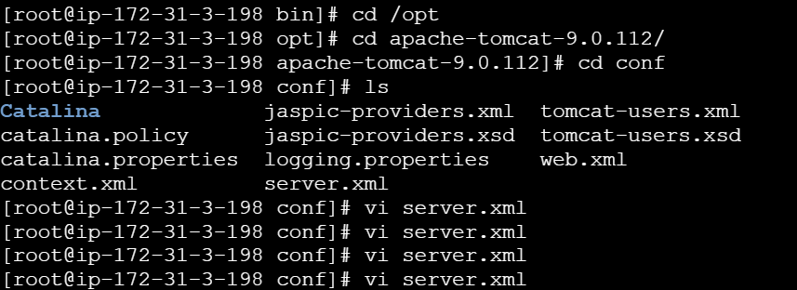
Step 5: then use /.startup.sh to Start the service and use /.shutdown.sh to shutdown the service
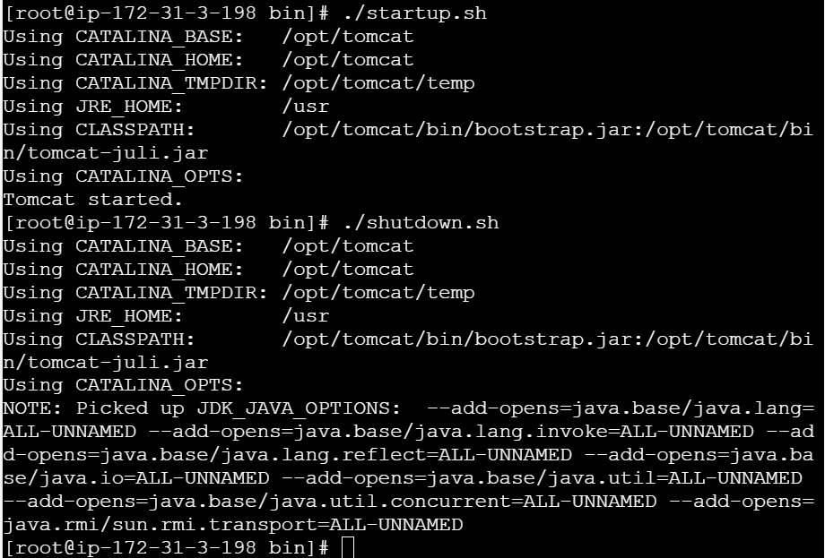
Verify on the browser
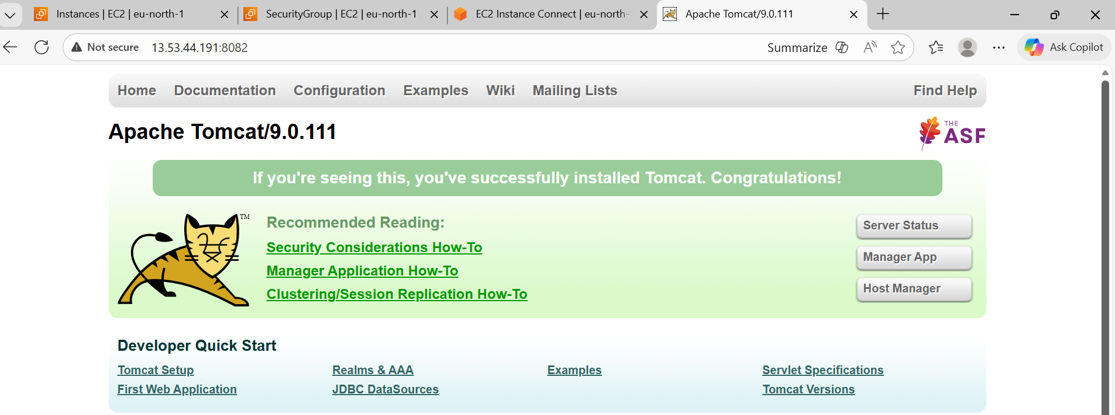

- Deploy a sample app on webapps
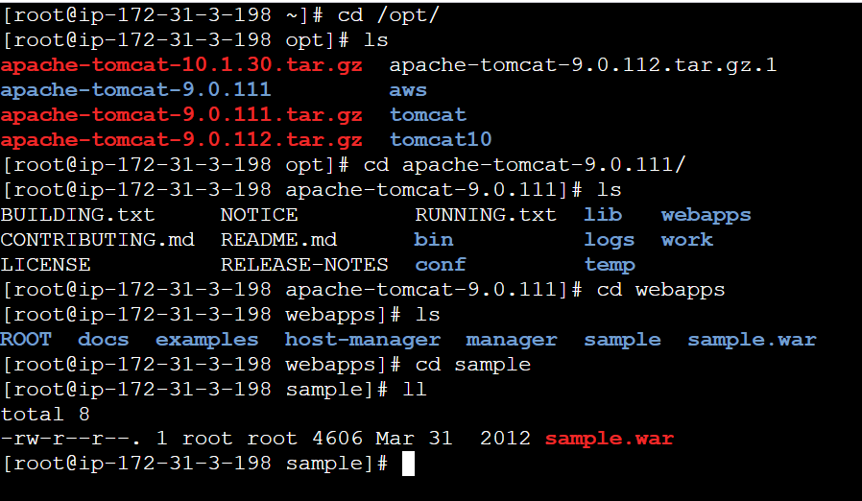

https://tomcat.apache.org/tomcat-7.0-doc/appdev/sample/sample.war
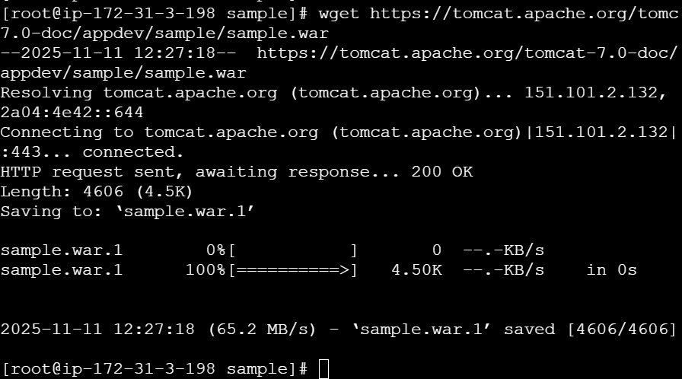

then change directory to sample
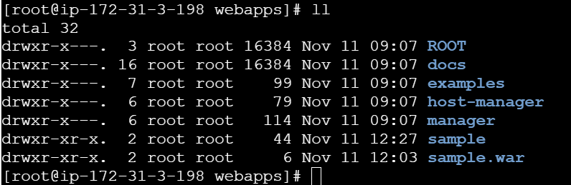
Find index.html file and edit using a sample file from browser---- copy and paste in linux.
Then verify the IPVP:8082/sample


- Create a tomcat.service file for tomcat.
To get a code from browser and pasted below: vi /etc/system/system/tomcat.service
Then java version changed
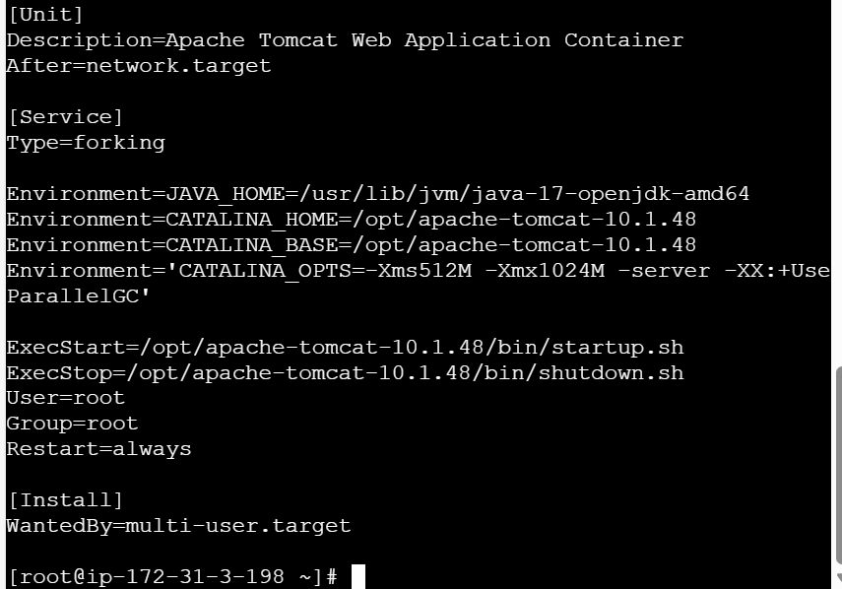
Change ownership of file and root access and permission to file.
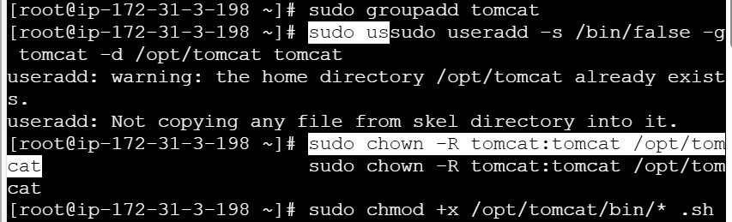
daemon-reload tells systemd to reload all its unit files (like .service,
.target, .socket, etc.) from disk.
In simpler terms:
It makes systemd notice new or changed service files — without
rebooting
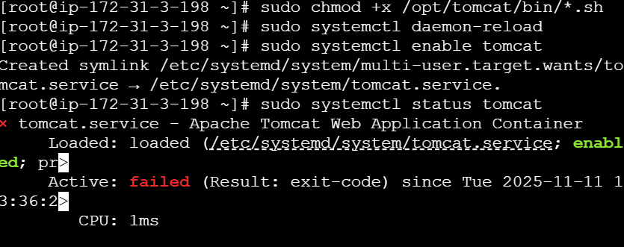
Then enabled tomcat service and check status

- Configure HA Proxy server
Opened 3 terminals- 1 for Httpd, 1 for nginx and 1 for Haproxy
Using ec2, I added 2 new servers except the 1 which I used for all installations.
In the 2 new servers, I used 80 port in Security groups
The below screenshot describes the httpd (apache tomcat) start and status using the pem.key from server 1 in aws.
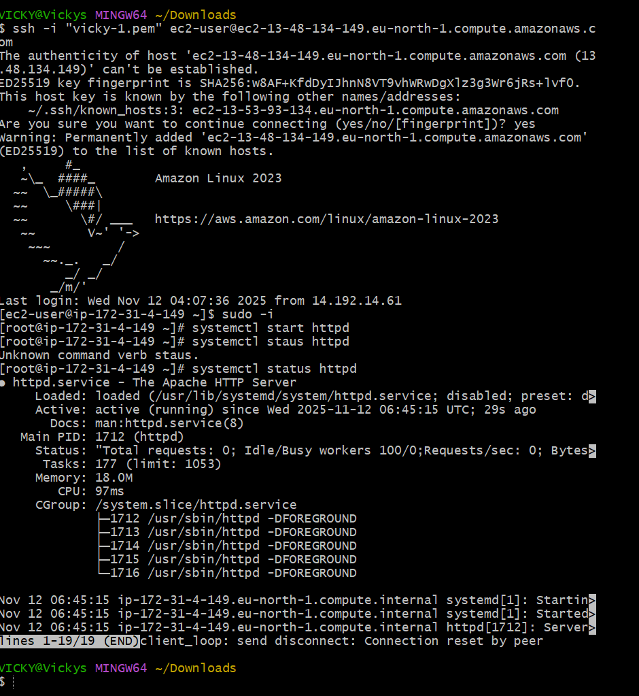
The second screenshot describes the commands used for nginx start and status using server 2 pem.key from aws.
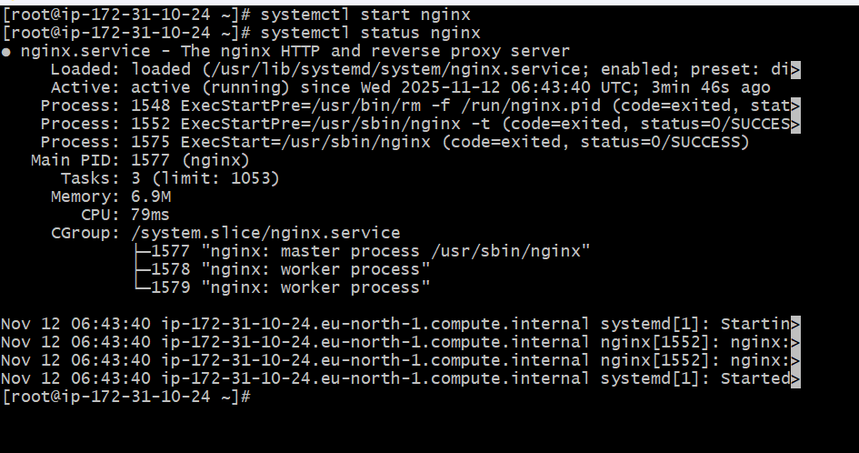
The third screenshot describes the Haproxy commands used from main server pem.key from aws.
Yum install Haproxy
vi /etc/hosts- 2 new servers to be added
vi /etc/Haproxy/Haproxy.cfg- 2 new servers to be added including port numbers
systemctl restart Haproxy
systemctl status Haproxy
The final step is to verify if all IPVP are working with port 80.
